1. How many users exist in the course server?

<https://www.cyberciti.biz/faq/linux-list-users-command/>

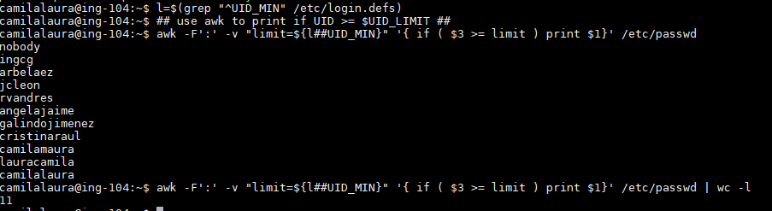l=$**(grep** "^UID_MIN" **/**etc**/**login.defs**)**

*## use awk to print if UID >= $UID_LIMIT ##*

**awk** -F':' -v "limit=${l##UID_MIN}" '{ if ( $3 >= limit ) print $1}' **/**etc**/passwd | wc -l**

1. What command will produce a table of Users and Shells sorted by shell (tip: using cut and sort)

<https://unix.stackexchange.com/questions/144705/use-cut-to-extract-a-list-from-etc-passwd>

pregunta- son solo uid o todos los users del sistema. Esa tabla es lo que quiere?

cut -f 1,7 -d: /etc/passwd | tr ":" " " | sort -k 1 |sort -k 2

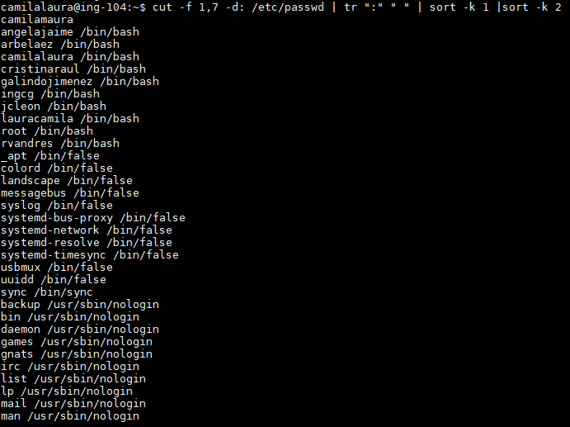

1. Create a script for finding duplicate images based on their content (tip: hash or checksum) You may look in the internet for ideas, Do not forget to include the source of any code you use.
2. Download the [bsds500](https://www2.eecs.berkeley.edu/Research/Projects/CS/vision/grouping/resources.html#bsds500) image segmentation database and decompress it (keep it in you hard drive, we will come back over this data in a few weeks).

scp "/drives/C/Users/Camila/Downloads/BSR_bsds500.tgz" .

scp ./BSR_bsds500.tgz camilalaura@157.253.63.53:~

1. What is the disk size of the uncompressed dataset, How many images are in the directory 'BSR/BSDS500/data/images'?

<http://www.tldp.org/HOWTO/Bash-Prompt-HOWTO/x700.html>

<https://unix.stackexchange.com/questions/185764/how-do-i-get-the-size-of-a-directory-on-the-command-line>

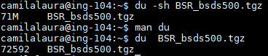

punto 7: du -sh BSR_bsds500.tgz

parte 2

ls -Rl ~/BSR/BSDS500/data/images/ | grep  jpg | wc -l



1. What is their resolution, what is their format?

punto 8.

paso 1: nos metemos al path

camilalaura@ing-104:~/BSR/BSDS500/data/images/test$

paso 2: encontramos las rutas  
rutas=`ls -d -1 $PWD/*.*` [ los ` son para que le asigne el resultado]

 paso 3: los identificamos

for im in $rutas; do identify $im; done

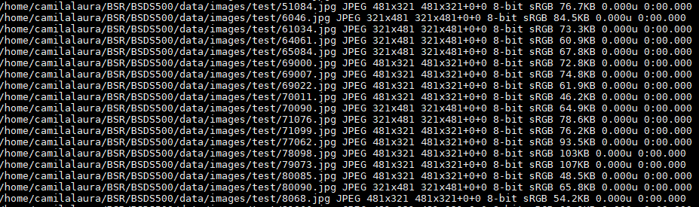

1. How many of them are in landscape orientation (opposed to portrait)?

punto 9 ya sabemos como encontrarlas

esta en prueba.sh falta contarlas y hacerlo en todas las carpetas

for f in ./*.jpg

do

r=$(identify -format '%[fx:(h>w)]' "$f")

if [[ r -eq 1 ]]

then

echo "$f" is portrait

else

echo "$f" is landscape

fi

done